IT8303

AI Human Interface
  - Lab 3
Deep Learning with Python
What you will learn / do in this lab
- Explore Deep Learning tools for Python
- Conduct experiment using PyTorch

TAble of
Contents
1. Overview 1
Introduction to PyTorch 2
2. PyTorch 4
Linear regresssion with PyTorch 4
3. Classifier with PyTorch 7

1.
Overview
Python is a popular language for Deep Learning. Several Deep Learning libraries or frameworks. Amount the two most popular for Python are TensorFlow and PyTorch.

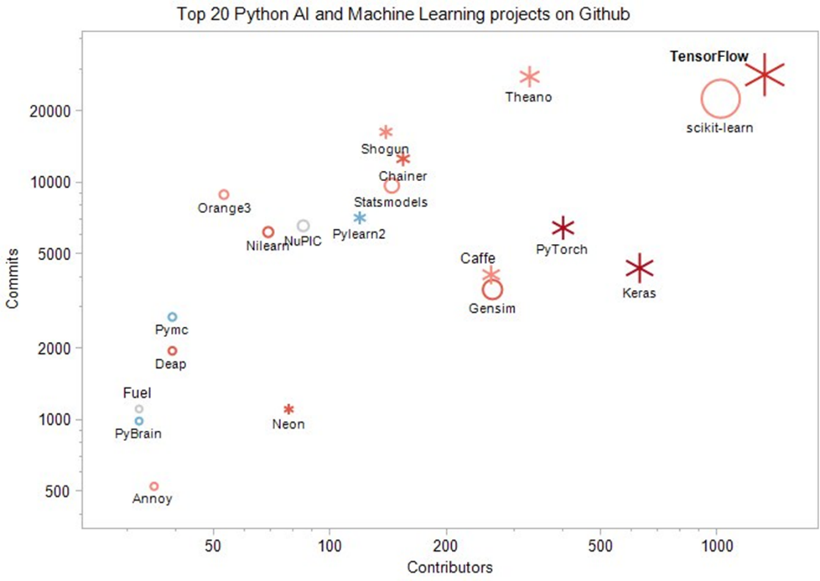

Introduction to PyTorch
PyTorch (http://pytorch.org) is an open-source machine learning framework designed to accelerate the path from research prototyping to production deployment. Its high-level API and optimized primitives, such as neural network layers and activation functions, make it exceptionally suited for a wide range of machine learning and deep learning algorithms.

PyTorch utilizes tensors as its core data abstraction for numerical computation, representing multidimensional arrays similar to NumPy but with built-in hardware acceleration. It is fundamentally based on a dynamic "define-by-run" paradigm where the computational graph is built on-the-fly during execution. This allows developers to use idiomatic Python and native control flow, such as loops and conditionals, while the Autograd engine automatically handles differentiation. This flexible architecture enables models to be serialized via TorchScript for deployment on servers or mobile devices.

PyTorch was originally developed by researchers and engineers at Meta AI (formerly Facebook AI Research) as a successor to the Lua-based Torch library. Its design was heavily influenced by the dynamic approach of the Chainer framework and the torch-autograd project. While initially created to facilitate rapid experimentation in deep neural networks, it has become widely adopted in diverse domains including computer vision, natural language processing, and robotics.

PyTorch can run on a CPU (no graphics accelerator), but it is optimized to run much faster on NVIDIA GPUs using CUDA bindings.

PyTorch Installation

Open your Anaconda Prompt


Type the following command to install the GPU version:

pip install torch torchvision --index-url https://download.pytorch.org/whl/cu126

If CPU version is preferred/required, skip the --index-url part.

pip install torch torchvision

After installation, you can use the command below to check whether the installation is successful

pip show torch

PyTorch Hello World

Here is a simple “Hello World” program to just test the installation. You can run the code in your Python Jupyter Notebook.

# PyTorch Hello World
import torch
print(torch.__version__)

# Create a simple tensor and add them
a = torch.tensor([1.0, 2.0, 3.0])
b = torch.tensor([4.0, 5.0, 6.0])
c = a + b
print(c)

It shows how you can define constants and perform computation with those constants.

2.
PyTorch
In this section, we will be using the PyTorch library to run some simple examples.

Computation in PyTorch is described in terms of data flow and operations in the structure of a directed graph.

- Nodes: Nodes perform computation and have zero or more inputs and outputs. Data that moves between nodes are known as tensors, which are multi-dimensional arrays of real values.
- Operation: An operation is a named abstract computation which can take input attributes and produce output attributes. For example, you could define an add or multiply operation.

Linear regresssion with PyTorch

This example shows how you can define variables (e.g. W and b) as well as variables that are the result of computation (y). W is the linear regression coefficient b1 and b is the constant.

y = b1*x + … b

We get some sense of PyTorch separates the definition and declaration of the computation from the execution in the session and the calls to run.

import torch
import torch.nn as nn
import matplotlib.pyplot as plt
import numpy as np
import time

# 1. Generate some synthetic data for linear regression
# We'll create data that roughly follows the line y = 2x + 1, with some noise
num_samples = 100
true_weight = 2.0
true_bias = 1.0

# Generating sample data with noise
x = np.random.rand(num_samples).astype(np.float32)
noise = 0.1 * np.random.randn(num_samples).astype(np.float32)
y = true_weight * x + true_bias + noise

# Split data into training and testing sets
train_ratio = 0.8
train_size = int(train_ratio * num_samples)
x_train, x_test = x[:train_size], x[train_size:]
y_train, y_test = y[:train_size], y[train_size:]

# 2. Define the linear regression model using PyTorch
model = nn.Linear(1, 1) # Simple linear model with 1 input and 1 output
print(model)

# 3. Define the loss function and optimizer
criterion = nn.MSELoss() # Mean Squared Error loss
optimizer = torch.optim.SGD(model.parameters(), lr=0.1)

# 4. Set to training mode
model.train()

# 5. Train the model
num_epochs = 100
for epoch in range(num_epochs):
start_time = time.time()
inputs = torch.from_numpy(x_train).unsqueeze(1) # Shape: [train_size, 1]
targets = torch.from_numpy(y_train).unsqueeze(1) # Shape: [train_size, 1]

optimizer.zero_grad() # Clear gradients
outputs = model(inputs) # Forward pass
loss = criterion(outputs, targets) # Compute loss
loss.backward() # Backward pass
optimizer.step() # Update parameters
end_time = time.time()

if (epoch+1) % 10 == 0:
print(f'Epoch [{epoch+1}/{num_epochs}], Loss: {loss.item():.4f}, Time: {end_time - start_time:.4f}s')

# 6. Calculate and print the loss on test set
model.eval()
with torch.no_grad():
test_inputs = torch.from_numpy(x_test).unsqueeze(1)
test_targets = torch.from_numpy(y_test).unsqueeze(1)
test_outputs = model(test_inputs)
test_loss = criterion(test_outputs, test_targets)
print(f'Test Loss: {test_loss.item():.4f}')

# 7. Make predictions on the test set
y_pred = test_outputs.squeeze().numpy() # Convert to numpy array for plotting

# Print the learned parameters
learned_weight = model.weight.item()
learned_bias = model.bias.item()
print(f'Learned weight: {learned_weight:.4f}, Learned bias: {learned_bias:.4f}')

# 8. Visualize the results (color training and test data with blue and red, respectively)
plt.scatter(x_train, y_train, label='Training data', color='blue')
plt.scatter(x_test, y_test, label='Test data', color='red')
plt.plot(x_test, y_pred, label='Fitted line', color='red')
# Can confirm that the prediction matches the learned parameters by plotting the line using the learned weight and bias
# x_line = np.linspace(0, 1, 100)
# y_line = learned_weight * x_line + learned_bias
# plt.plot(x_line, y_line, label='Learned line', color='green', linestyle='--')
plt.title('Linear Regression Fit')
plt.xlabel('x')
plt.ylabel('y')
plt.legend()
plt.show()

3.
Classifier with PyTorch
We will will use PyTorch to build a classifier for the Iris data set to show the full machine learning workflow.

import torch
import torch.nn as nn
import matplotlib.pyplot as plt
import numpy as np
import time

# Load Iris dataset
from sklearn.datasets import load_iris
iris = load_iris()
X = iris.data
y = iris.target

# Split into training, validation, and test sets (80:10:10)
from sklearn.model_selection import train_test_split
X_train, X_temp, y_train, y_temp = train_test_split(X, y, test_size=0.2, random_state=42)
X_val, X_test, y_val, y_test = train_test_split(X_temp, y_temp, test_size=0.5, random_state=42)

# Scale the features using StandardScaler
from sklearn.preprocessing import StandardScaler
scaler = StandardScaler()
X_train_scaled = scaler.fit_transform(X_train) # Fit on training data only
X_val_scaled = scaler.transform(X_val)
X_test_scaled = scaler.transform(X_test)

# Train a simple linear feedforward neural network for classification
model = nn.Sequential(
nn.Linear(4, 10), # Input layer (4 features) to hidden layer
nn.ReLU(),
nn.Linear(10, 3), # Hidden layer to output layer (3 classes)
)

# Train the model
model.train()
criterion = nn.CrossEntropyLoss() # Cross-Entropy loss for classification
optimizer = torch.optim.SGD(model.parameters(), lr=0.1)
num_epochs = 100
for epoch in range(num_epochs):
start_time = time.time()
inputs = torch.from_numpy(X_train_scaled).float() # Shape: [train_size, 4]
targets = torch.from_numpy(y_train).long() # Shape: [train_size]

optimizer.zero_grad() # Clear gradients
outputs = model(inputs) # Forward pass
loss = criterion(outputs, targets) # Compute loss
loss.backward() # Backward pass
optimizer.step() # Update parameters
end_time = time.time()

# Calculate training loss and accuracy
_, predicted = torch.max(outputs, 1)
correct = (predicted == targets).sum().item()
train_accuracy = correct / len(y_train)

with torch.no_grad():
# Evaluate on validation set
val_inputs = torch.from_numpy(X_val_scaled).float()
val_targets = torch.from_numpy(y_val).long()
val_outputs = model(val_inputs)
_, predicted = torch.max(val_outputs, 1)
correct = (predicted == val_targets).sum().item()
val_accuracy = correct / len(y_val)

if (epoch+1) % 10 == 0:
print(f'Epoch [{epoch+1}/{num_epochs}], Loss: {loss.item():.4f}, Train Accuracy: {train_accuracy:.4f}, Val Accuracy: {val_accuracy:.4f}, Time: {end_time - start_time:.4f}s')

It would print something like this:
Epoch [10/100], Loss: 0.8482, Train Accuracy: 0.8000, Val Accuracy: 0.8667, Time: 0.0020s
Epoch [20/100], Loss: 0.6474, Train Accuracy: 0.8167, Val Accuracy: 0.9333, Time: 0.0021s
Epoch [30/100], Loss: 0.5152, Train Accuracy: 0.8333, Val Accuracy: 0.9333, Time: 0.0010s
Epoch [40/100], Loss: 0.4384, Train Accuracy: 0.8333, Val Accuracy: 0.9333, Time: 0.0010s
Epoch [50/100], Loss: 0.3893, Train Accuracy: 0.8750, Val Accuracy: 0.9333, Time: 0.0015s
Epoch [60/100], Loss: 0.3540, Train Accuracy: 0.8833, Val Accuracy: 1.0000, Time: 0.0024s
Epoch [70/100], Loss: 0.3268, Train Accuracy: 0.8917, Val Accuracy: 1.0000, Time: 0.0020s
Epoch [80/100], Loss: 0.3048, Train Accuracy: 0.9083, Val Accuracy: 1.0000, Time: 0.0010s
Epoch [90/100], Loss: 0.2858, Train Accuracy: 0.9083, Val Accuracy: 1.0000, Time: 0.0000s
Epoch [100/100], Loss: 0.2690, Train Accuracy: 0.9083, Val Accuracy: 1.0000, Time: 0.0010s

And then we can test it on the test data:
# Test on the test set
model.eval() # Set the model to evaluation mode
with torch.no_grad():
test_targets = torch.from_numpy(y_test).long()
test_inputs = torch.from_numpy(X_test_scaled).float()
test_outputs = model(test_inputs)
_, predicted = torch.max(test_outputs, 1)
correct = (predicted == test_targets).sum().item()
test_accuracy = correct / len(y_test)
print(f'Test Accuracy: {test_accuracy:.4f}')

To get:
Test Accuracy: 0.9333

